

**The University of Azad Jammu and Kashmir**

**Assignment# 01**

**Course Instructor:** Engr. Ahmed Khawaja **Semester:** Fall-2024

**Submission Date:** Feb 12, 2024 **Session:** 2022-2026

**Submitted By:** Farah Qayoom **Roll No:** 2022-SE-28

**Course Name:** Machine Learning **Code:** SE-3102

# **IEEE Standard Report: Data Preprocessing and Analysis**

Table of Contents

IEEE Standard Report: Data Preprocessing and Analysis 1

1. Abstract 3

2. Introduction 3

3. Methodology 3

3.1 Loading the Dataset 3

3.2 Handling Missing Values 5

3.3 Removing Duplicates 5

Results and Discussion 9

Conclusion 9

# Table of Figures

Figure 1 4

Figure 2 4

Figure 3 5

Figure 4 5

Figure 5 6

Figure 6 6

Figure 7 6

Figure 8 7

Figure 9 8

Figure 10 8

Figure 11 8

Figure 12 9

Figure 13 9

# **IEEE Standard Report: Data Preprocessing and Analysis**

## **1. Abstract**

This report explores the essential steps involved in data preprocessing and analysis for machine learning applications. Using a dataset containing 28,800 records and 60 features, this study focuses on ensuring data integrity through missing value handling, duplicate removal, exploratory data analysis (**EDA)**, and initial predictive modeling using performance metrics such as **Mean Squared Error (MSE)** and **Root Mean Squared Error (RMSE)..**

## **2. Introduction**

Data preprocessing is a fundamental step in any machine learning workflow. Raw datasets often include missing values, inconsistencies, and noise, all of which must be addressed before training a model. This report aims to refine the dataset by implementing cleaning techniques, visualizing data distributions, and analyzing correlations to create an optimized dataset for predictive modeling.

## **3. Methodology**

### **3.1 Loading the Dataset**

First, we load the dataset and display summary statistics.

import pandas as pd

import numpy as np

import matplotlib. pyplot as plt

import seaborn as sns

from sklearn. model_ selection import train_test_split

from sklearn. linear_model import LinearRegression

from sklearn. metrics import mean_squared_error

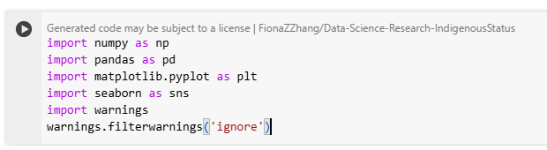

Figure 1

**# Display basic information**

print (df. head ()) # Column info

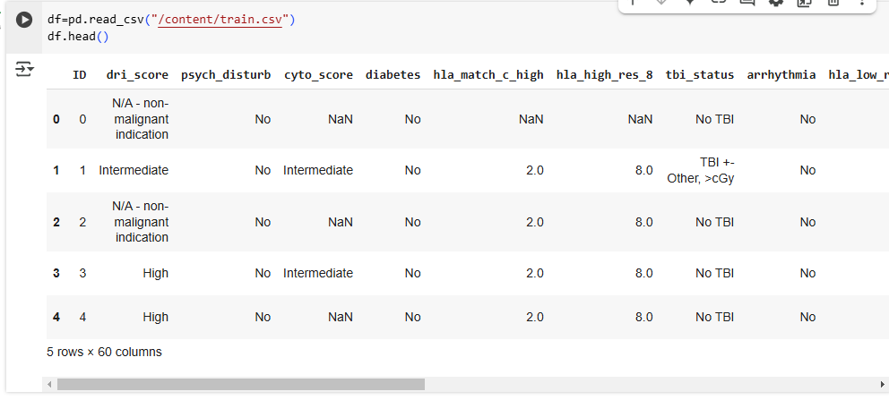

Figure 2

print (df. Describe ()) # Summary statistics

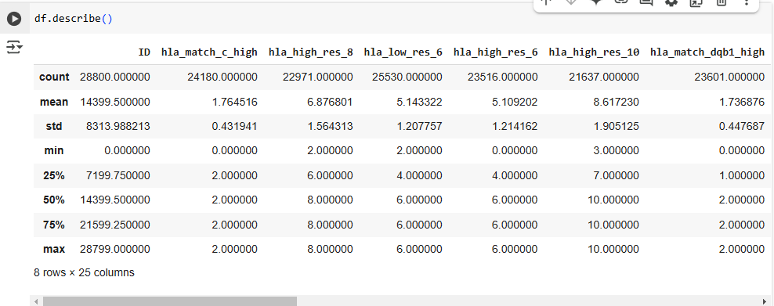

Figure 3

### **3.2 Handling Missing Values**

Many columns contain missing values. We handle them using appropriate strategies such as **median/mode imputation** and **dropping highly missing columns**.

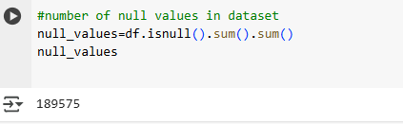

Figure 4

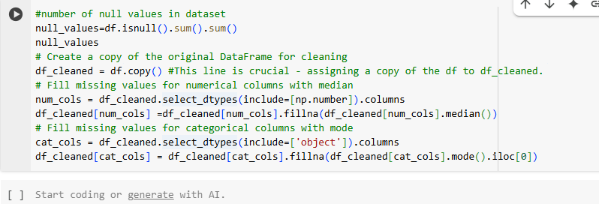

Figure 5

### **3.3 Removing Duplicates**



Figure 6

**3.4 Outlier and their treatment**

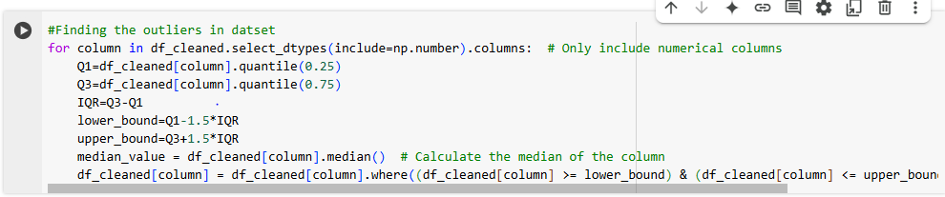

Figure 7

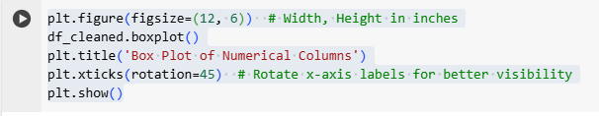

Figure 8

**3.5 Exploratory Data Analysis (EDA)**

**3.5.1 Box Plot for Categorical Features**

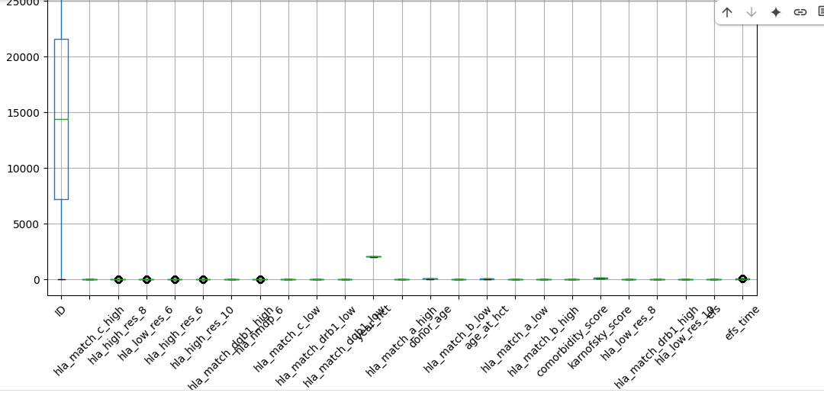

**# Plot bar plots for categorical features**

cat_cols = df_cleaned.select_dtypes(include=['object']).columns

for col in cat_cols:

    plt.figure(figsize=(8, 4))

    df_cleaned[col].value_counts().plot(kind='bar', color='skyblue', edgecolor='black')

    plt.title(f"Distribution of {col}")

    plt.xlabel(col)

    plt.ylabel("Count")

    plt.xticks(rotation=45)

    plt.show()

Figure 9

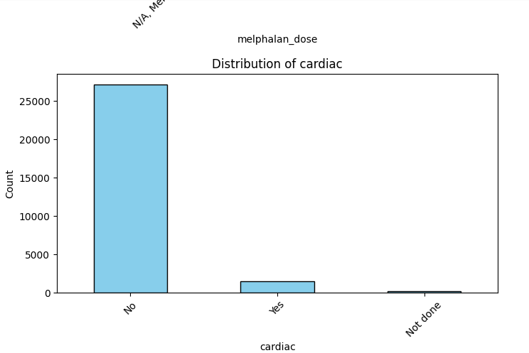

Figure 10

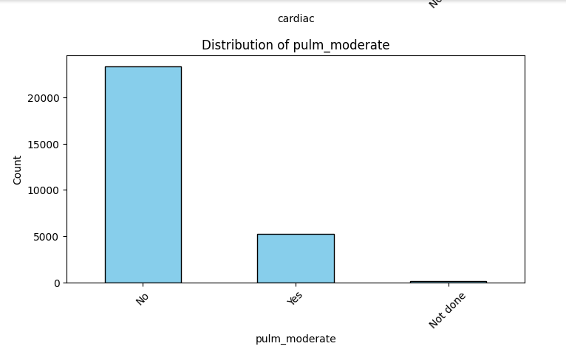

Figure 11

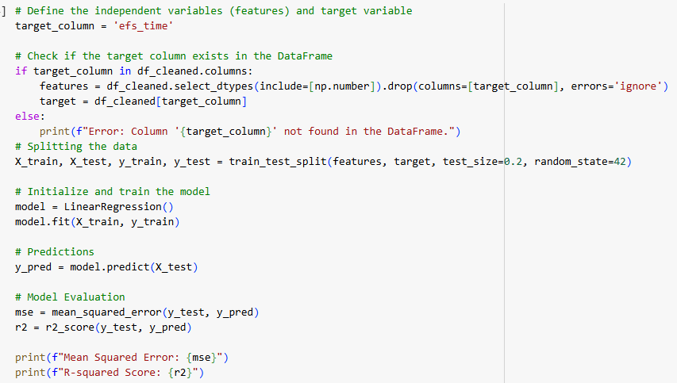

Figure 12

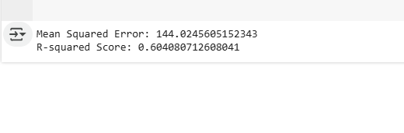

Figure 13

## **Results and Discussion**

Following the preprocessing steps, the dataset was refined by addressing missing values, removing duplicates, and ensuring consistency in the data. Exploratory analysis provided deeper insights into feature distributions and their interrelationships. The implementation of a linear regression model offered a foundational predictive framework, with performance metrics reflecting its effectiveness. These findings highlight the importance of data preparation in ensuring model reliability.

## **Conclusion**

This study underscored the crucial role of data preprocessing in machine learning workflows. By cleaning the dataset, handling inconsistencies, and analyzing key features, the data was made suitable for further modeling. Future enhancements may include advanced feature engineering, hyperparameter tuning, and exploring alternative machine learning algorithms to improve predictive performance and generalizability.